CONTENT:

-----------------------------------------------------------------------------

1. LEACH Protocol (Low-Energy Adaptive Clustering Hierarchy)
2. DEECP (Distributed Energy-Efficient Clustering Protocol)
3. Enhanced DEECP (author’s improved version)
4. Q-Learning based Cluster Head (CH) Selection (my improved version)
5. **LEACH (Low-Energy Adaptive Clustering Hierarchy) Protocol**

* LEACH is one of the earliest and most popular hierarchical routing protocols designed to minimize energy consumption in Wireless Sensor Networks (WSNs)
* Key Characteristics:

1. Clustering-Based: Nodes are organized into clusters, each with a Cluster Head (CH).
2. Random CH Selection: CHs are chosen on probability to balance energy load.
3. TDMA/CDMA: LEACH uses TDMA to avoid intra-cluster collisions and CDMA for inter-cluster communication.
4. Rounds-Based: Network operation is divided into rounds, each with two phases:
5. Setup Phase: CH selection and cluster formation.
6. Steady-State Phase: Data transmission.

v. Cluster Head (CH) Selection Formula:

Each node becomes a CH with probability p using a threshold T(n):

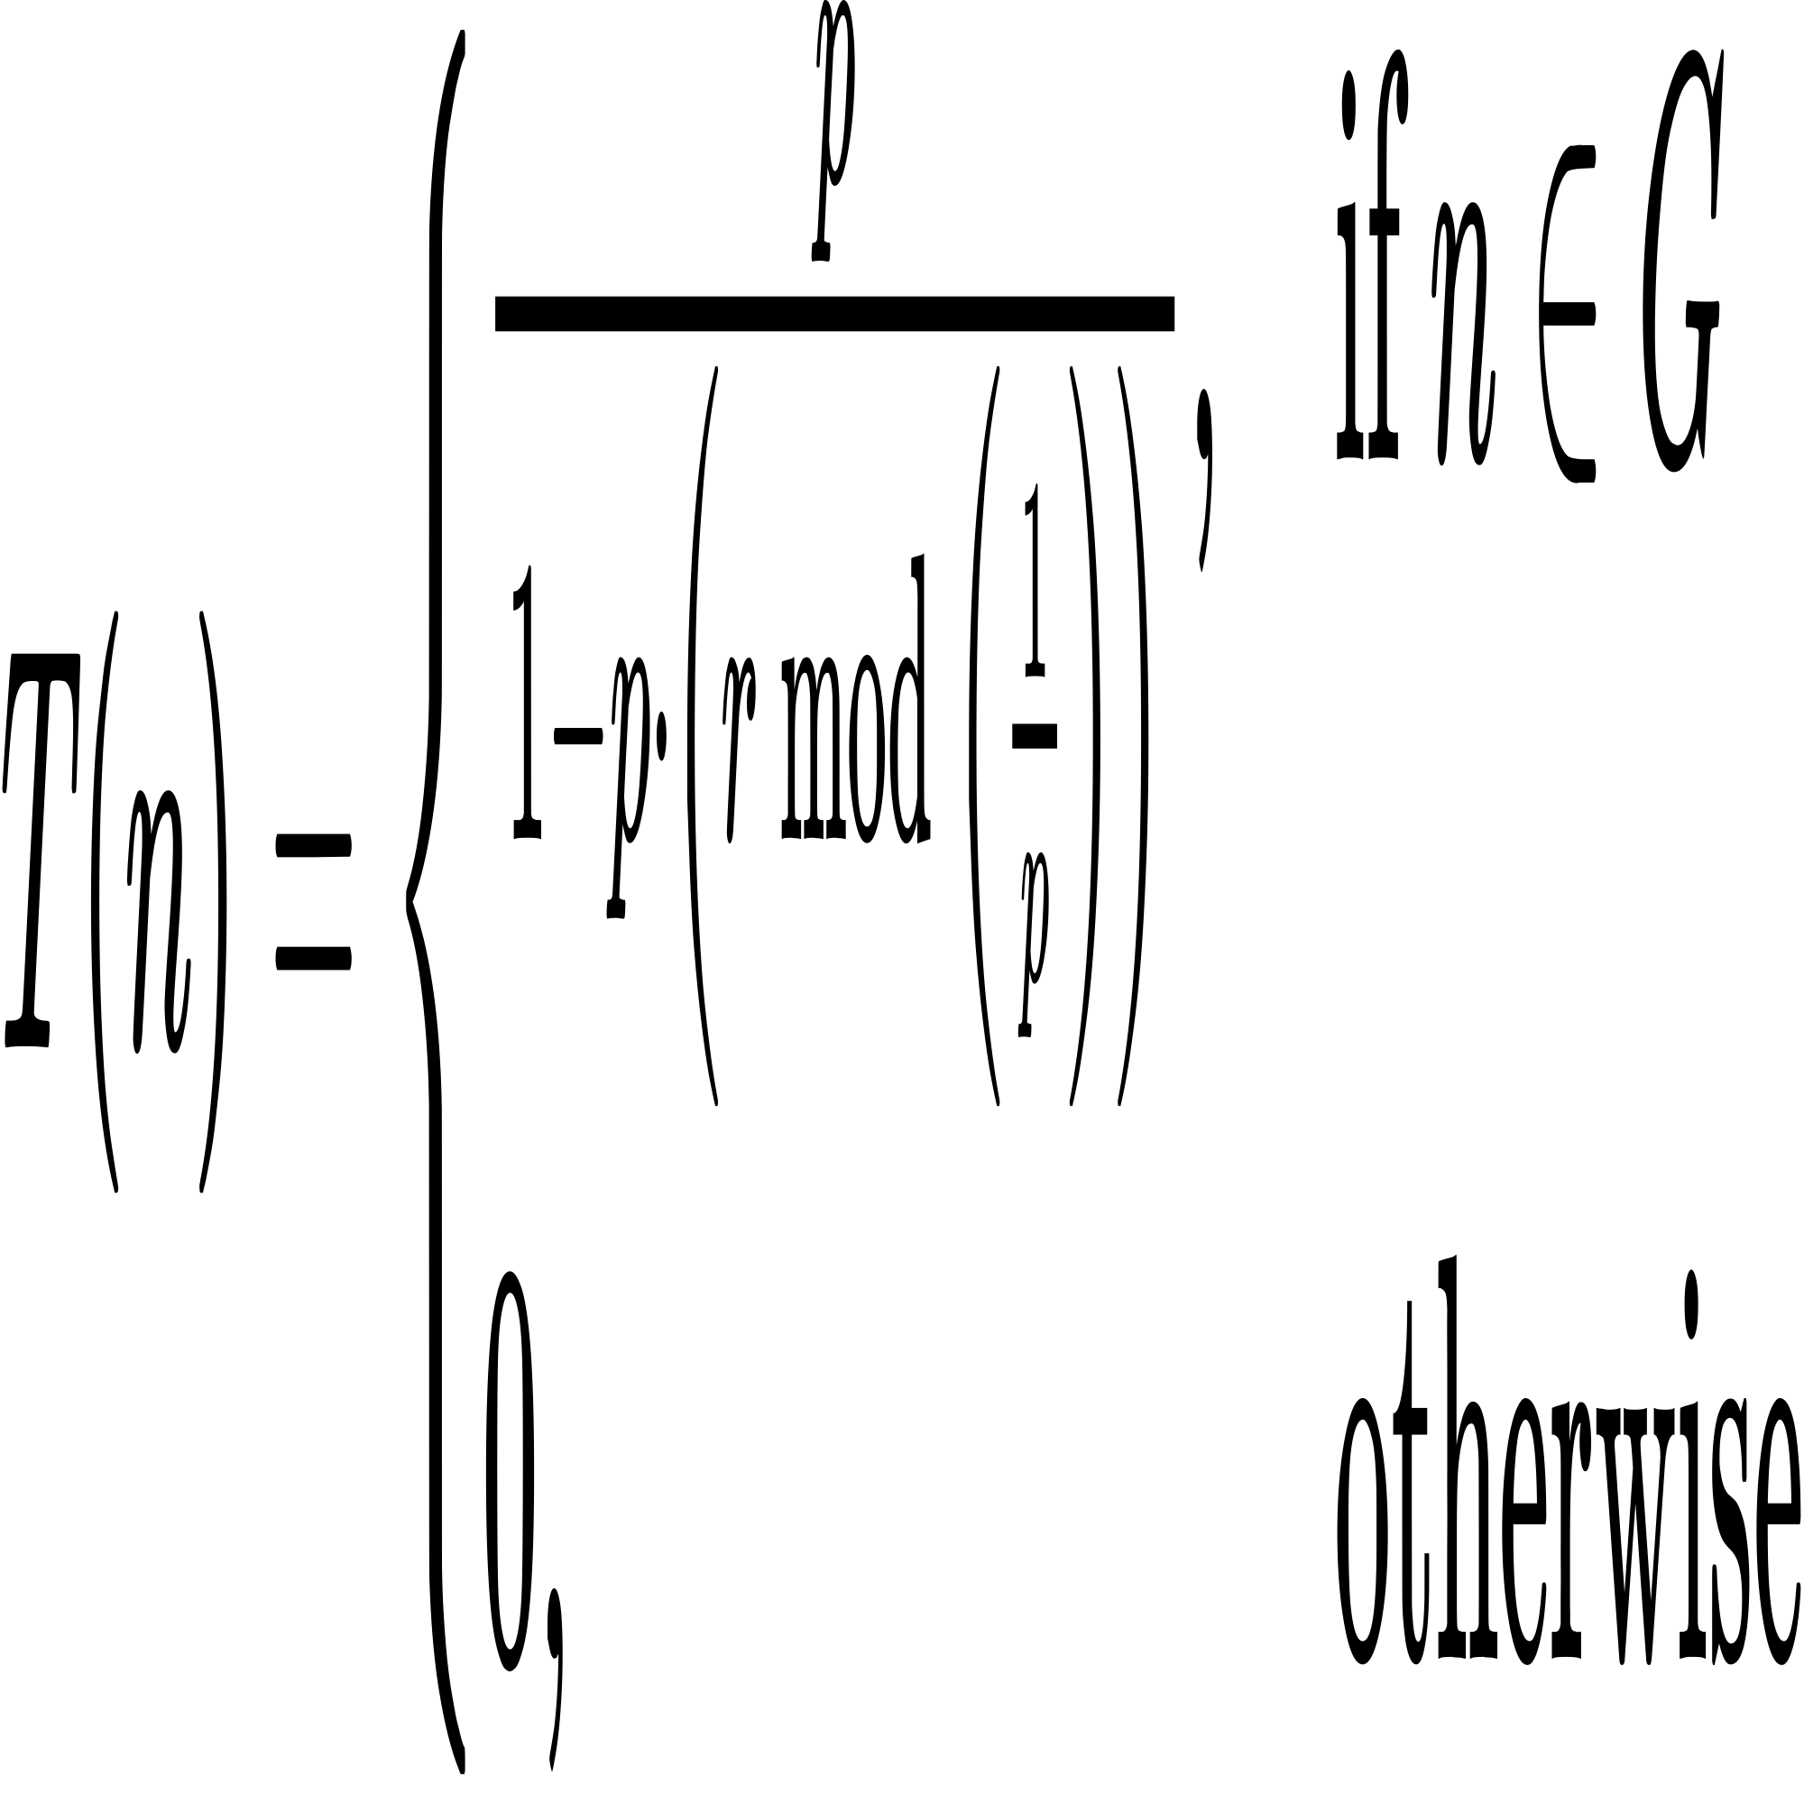

Where:

T(n) = Threshold for node n to become CH

p = Desired percentage of CHs per round

r = Current round number

G = Set of nodes that have not been CHs in the last 1/p rounds

* Advantages:

1. Simple and distributed.
2. Prolongs network lifetime by rotating CH role.

* Limitations:

1. Random CH selection can lead to poor distribution.
2. Not energy-aware (doesn't consider residual energy).
3. Only works well in homogeneous environments.

**LEACH: Operation in Practice:**

Suppose we have 100 sensor nodes deployed in a large agricultural field to monitor soil moisture. Each sensor has limited battery. If every node sends its data directly to the base station (sink) every time, the nodes farthest from the base station will consume more energy and die quickly and leads to network partition. LEACH comes to the rescue by grouping nodes into clusters with a leader (CH) that aggregates data from members and sends it to the base station.

**Step-by-Step Working of LEACH:**

**Step 1: Setup Phase**

This phase happens at the start of each round.

1.1 Cluster Head Selection

Each node decides whether to become a CH based on probability p (e.g., p = 0.05 → 5% of nodes are CHs in a round).

Let’s say Node 7 generates a random number (0 to 1), and it’s less than the threshold T(n). It elects itself as a CH.

1.2 Cluster Formation

CHs broadcast an advertisement (ADV) message:

“Hello, I’m a Cluster Head. Join me!”

Each non-CH node picks the nearest CH (based on RSSI) and sends a join-request message.

Now the clusters are formed.

**Step 2: Steady-State Phase**

Now clusters are ready.

2.1 Data Transmission

Each CH creates a TDMA schedule and shares time slots with its members.

During their time slot, member nodes wake up, send data, and go back to sleep (to save power).

CH aggregates data from all members, compresses it, and sends one single packet to the base station.

1. **DEECP (Distributed Energy-Efficient Clustering Protocol)**

* To enhance the lifetime and stability of Wireless Sensor Networks (WSNs) by making Cluster Head (CH) selection energy-aware, unlike LEACH which is purely probabilistic.

DEECP introduces residual energy and average energy of the network as part of the CH selection logic.

* Key Characteristics:

1. Heterogeneous Network: Unlike LEACH, DEECP assumes the WSN contains
2. Normal nodes (basic energy)
3. Advanced nodes (more energy)
4. Cluster Head (CH) Selection: DEECP selects CHs based on a weight function that considers
5. Node’s residual energy
6. Average residual energy of the network.
7. DEECP CH Probability Equations

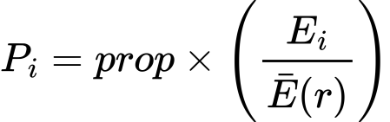

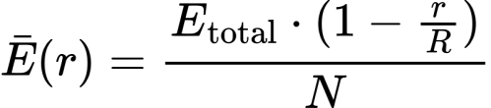

C:/Users/SHUBHAM/AppData/Local/Temp/wps.zycFoawps

Where:

𝑃𝑖 = Probability of node i becoming a CH

Ei = Residual energy of node i

E(r) = Average residual energy of the network at round r

prop = Optimal CH probability

Wi = Weight factor based on node type or distance

m = Faction of advance node

N = Total numbers of nodes

R = Total numbers of rounds

1. DEECP Weight Function

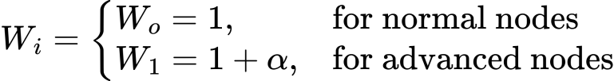

Where:

α = Heterogeneity factor that defines how much more energy an advanced node has compared to a normal node.

1. CH Threshold Function

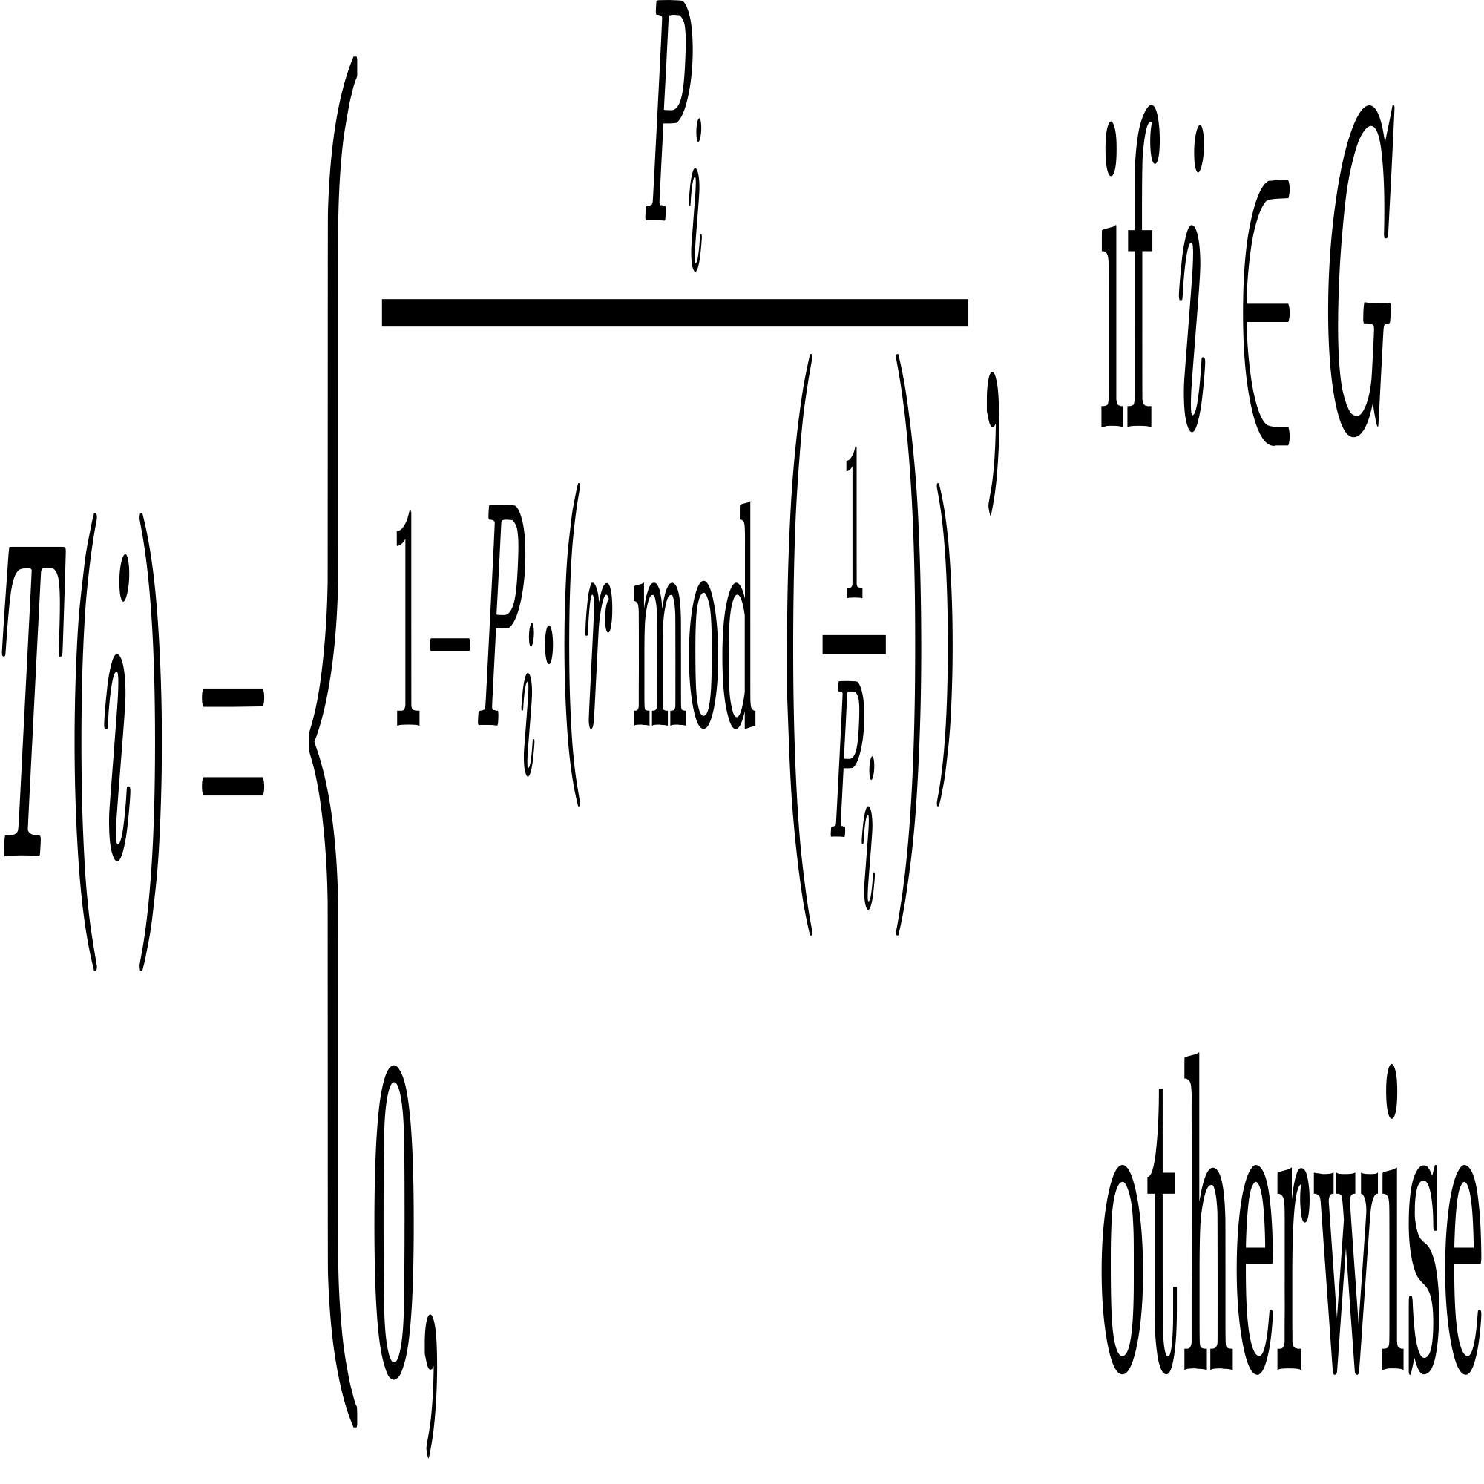

Where:

T(n) = Threshold for node n to become CH

𝑃𝑖 = Probability of node i becoming a CH

r = Current round number

G = Set of nodes that have not been CHs in the last 1/Pi rounds

* Advantages:

1. Energy-Aware CH Selection
2. Supports Node Heterogeneity
3. Simple and Distributed
4. Extended Network Lifetime

* Limitations:

1. No Distance Optimization
2. No CH Load Balancing
3. No inter cluster hoping
4. Not consider different sensor energy level

**DEECP: Operation in Practice:**

Suppose we have 100 sensor nodes deployed in an agricultural field for soil moisture monitoring. The network is heterogeneous, meaning, 80 normal nodes have initial energy Eo and 20 advanced nodes have higher energy Eo(1 + α)

If every node transmits directly to the base station, faraway nodes die quickly. DEECP overcomes this by using energy-aware clustering, where nodes with higher residual energy and better energy capacity are more likely to become Cluster Heads (CHs).

**Step-by-Step Working of DEECP:**

**Step 1: Setup Phase**

Occurs at the start of each round.

* 1. Energy-Aware Cluster Head (CH) Selection

Using above formulae the CH selection happens

Then threshold calculation and CH declaration If the random number ≤ T(i), node becomes a CH.

1.2 Cluster Formation

CHs broadcast an advertisement (ADV) message:

“Hello, I’m a Cluster Head. Join me!”

Each non-CH node picks the nearest CH (based on RSSI) and sends a join-request message.

Now the clusters are formed.

**Step 2: Steady-State Phase**

This step is exact similar to LEACH protocol

1. **Enhanced DEECP (Proposed by the author)**

* Enhanced DEECP introduces multi-level node heterogeneity, i.e., Normal, Advanced, and Super nodes with different energy levels and adds distance awareness to improve Cluster Head (CH) selection efficiency.
* Key Characteristics:

1. Multi-Heterogeneous Network: Enhanced DEECP assumes the WSN contains three types of nodes
2. Normal nodes (basic energy Eo)
3. Advanced nodes (higher energy Eo(1 + α))
4. Super nodes (even higher energy Eo(1 + β))

1. Cluster Head (CH) Selection: Enhanced DEECP selects CHs using a weighted probability function considering
2. Residual energy of the node
3. Average residual energy of the network
4. Weight factor based on node type
5. Distance between node and base station
6. CH Probability Equation:

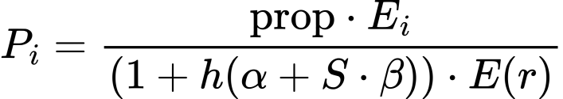

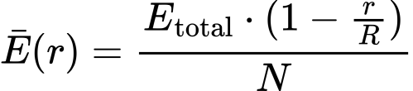

C:/Users/SHUBHAM/AppData/Local/Temp/wps.pQQRUdwps

Where:

𝑃𝑖 = Probability of node i becoming a CH

E𝑖 = Residual energy of node i

E(r) = Average residual energy of the network at round r

prop = Optimal CH probability

Wi = Weight factor based on node type or distance

m = Faction of advance node

m0 = Fraction of super nodes

N = Total numbers of nodes

R = Total numbers of rounds

1. Enhanced DEECP Weight Function

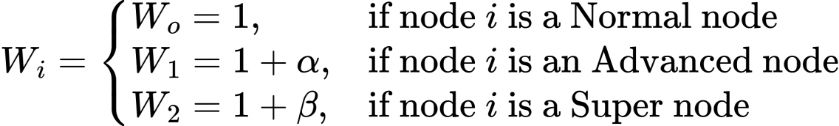

Where:

α = Heterogeneity factor that defines how much more energy an advanced node has compared to a normal node.

β = Heterogeneity factor that defines how much more energy an super node has compared to a normal node.

1. CH Threshold Function

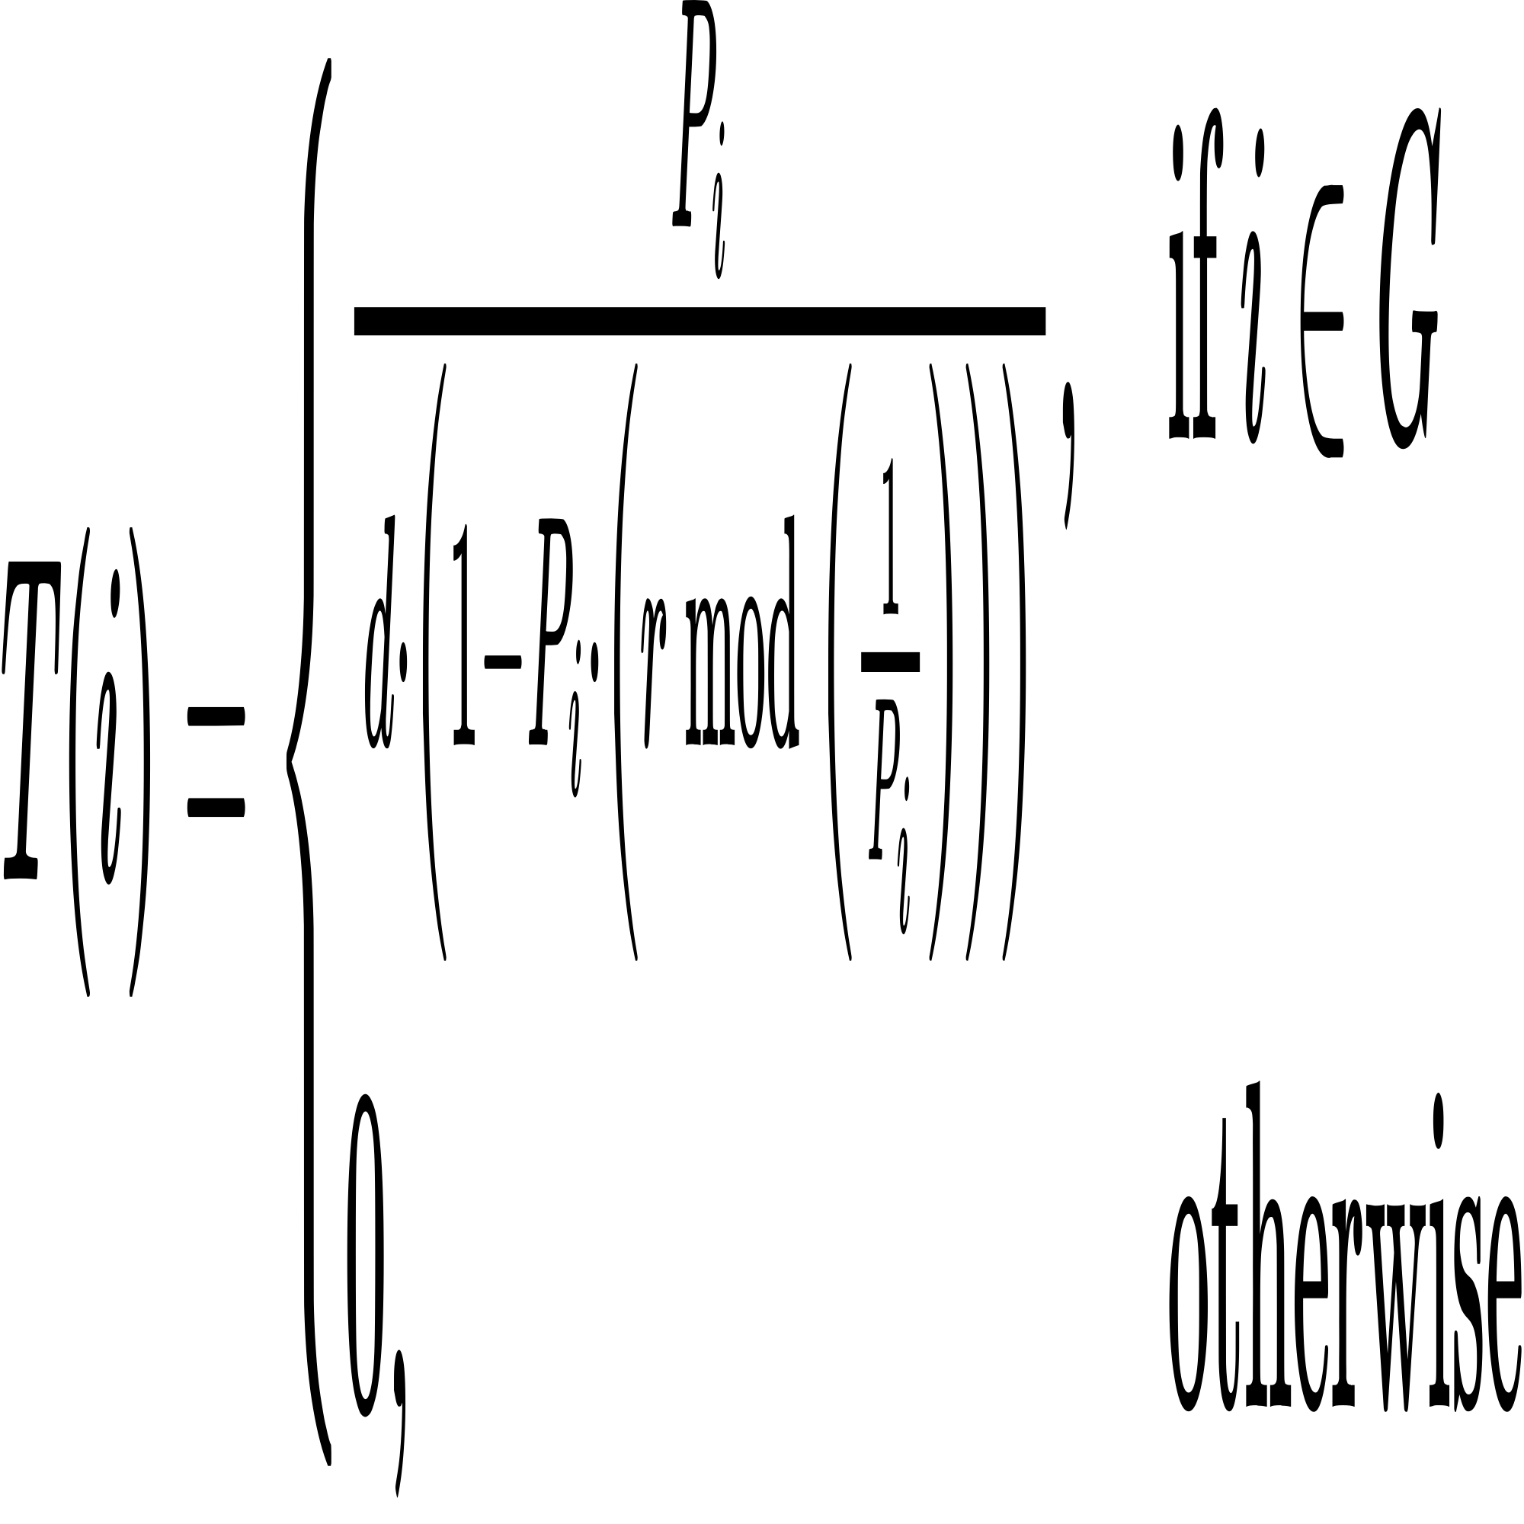

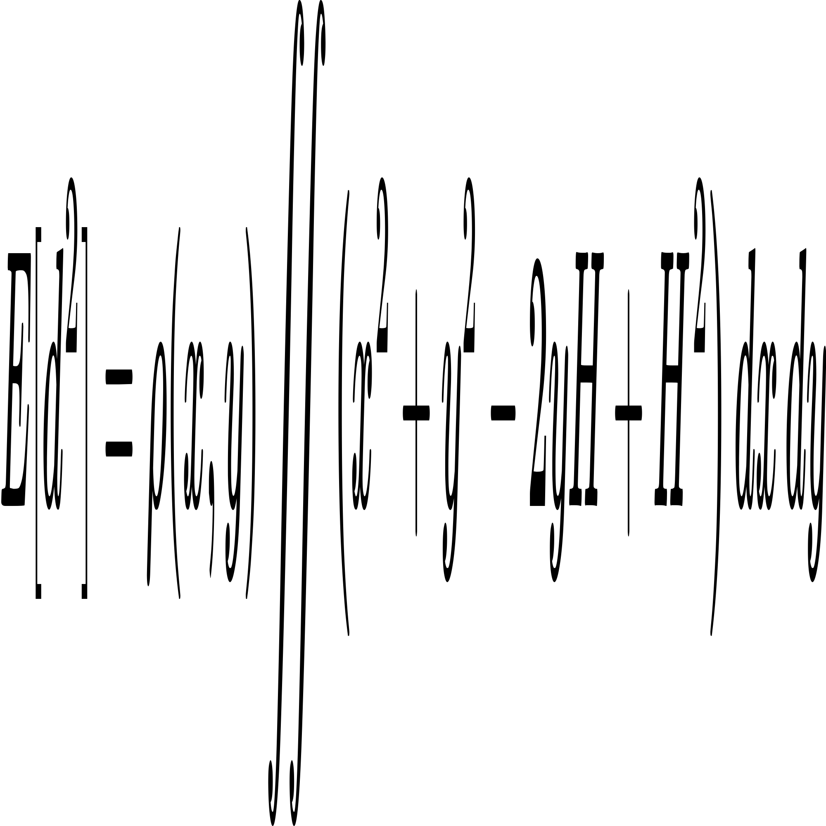

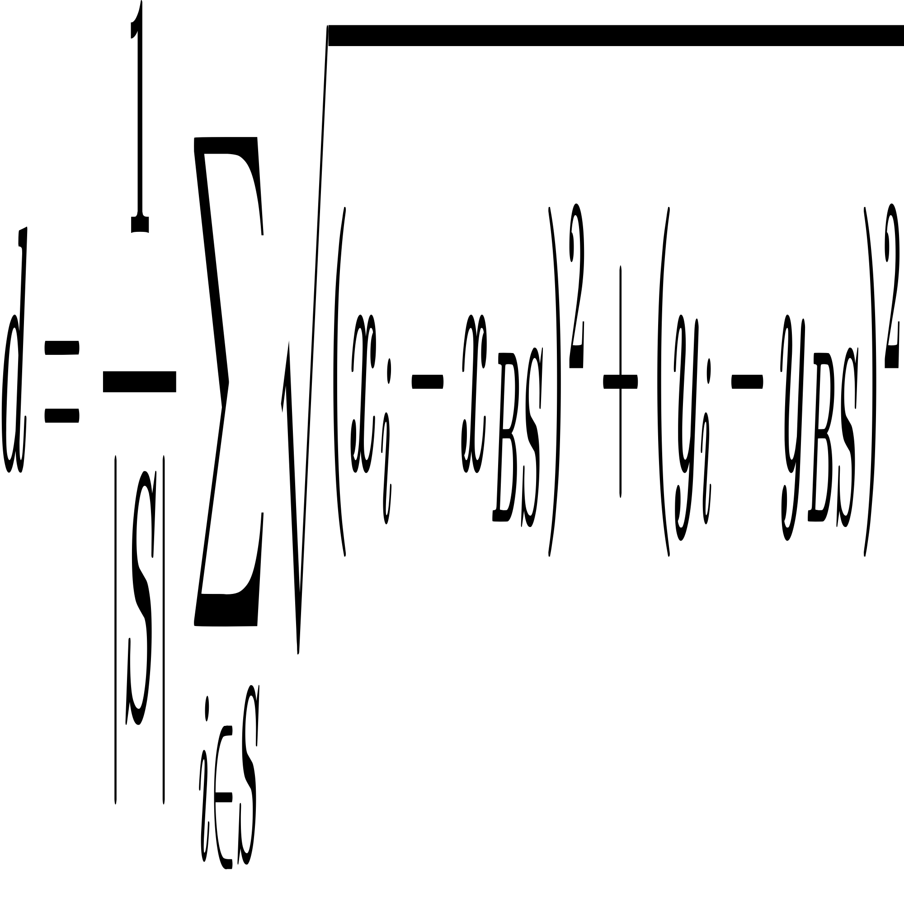

Where:

T(n) = Threshold for node n to become CH

𝑃𝑖 = Probability of node i becoming a CH

r = Current round number

G = Set of nodes that have not been CHs in the last 1/Pi rounds

d = Average distance from node $i$ to the base station

E[sq(d)] = Expected squared distance between node and base station

(x, y) = Coordinates of a node

(0, H) = Coordinateof base station

roh(x, y) = Probability distribution function of node positions

1. Energy Model:

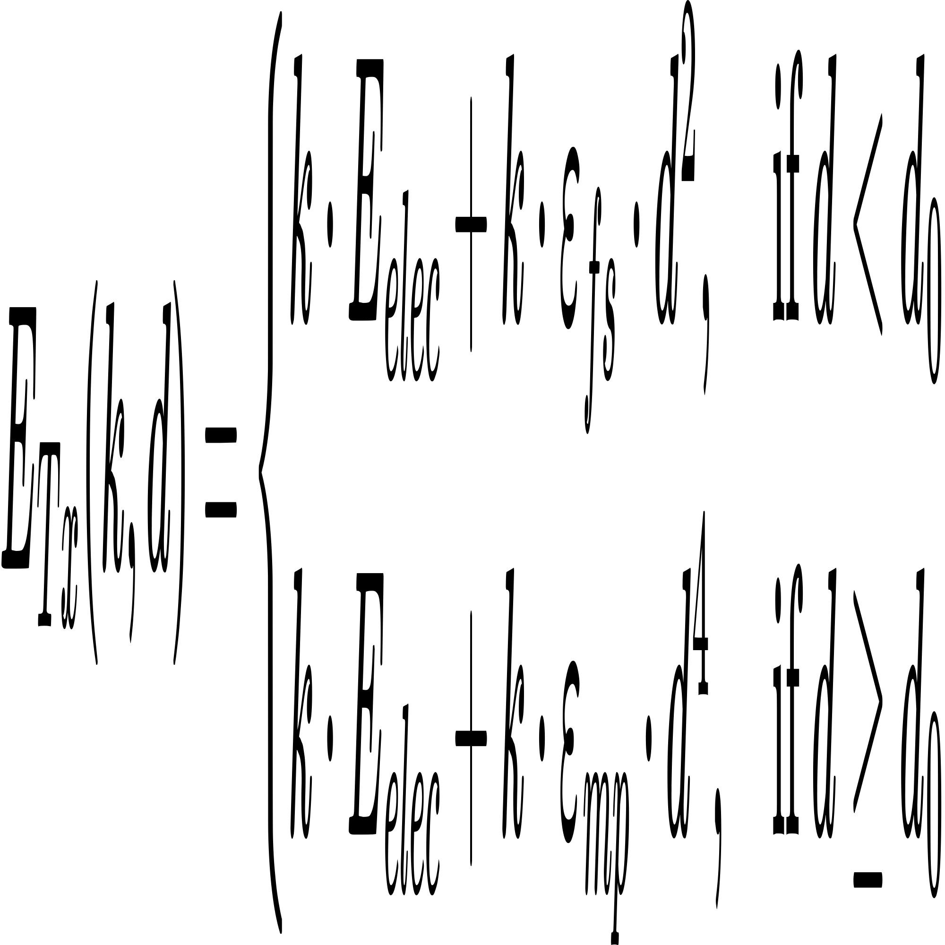

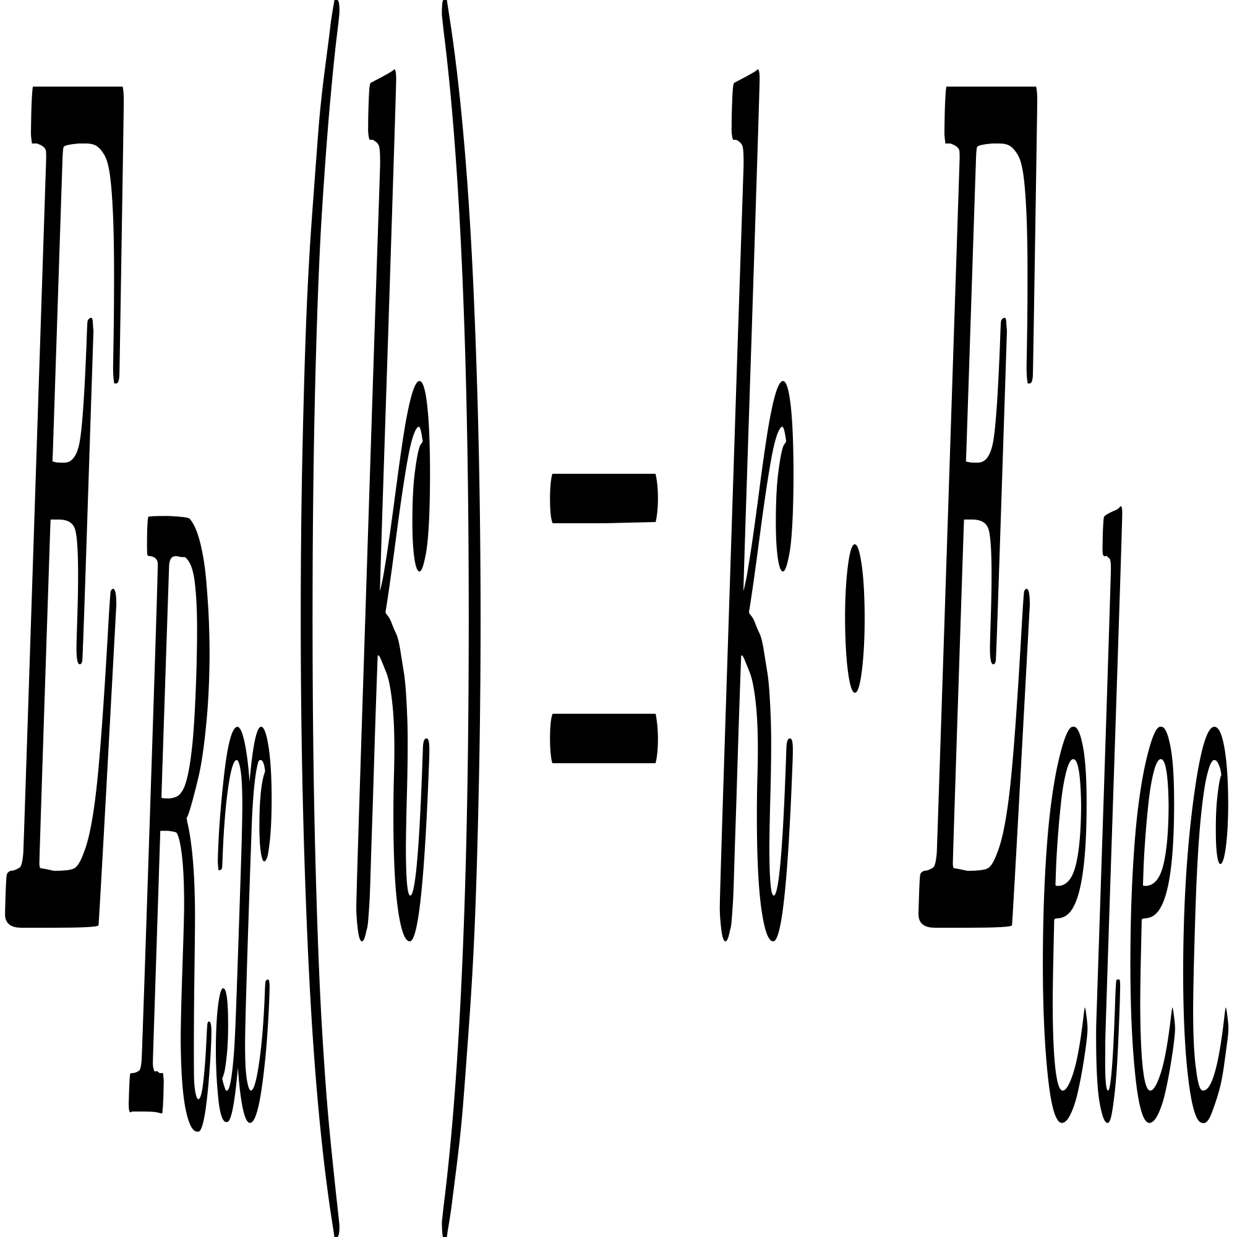

wps

wps

Where:

k = Size of the data packet in bits

E_elec: Energy required per bit for transmission/reception circuitry

epsilon_fs: Amplifier energy for free-space model

epsilon_mp: Amplifier energy for multi-path model

d: Distance between sender and receiver

d_0: Threshold distance to switch between free-space and multipath

E_DA: Energy required for data aggregation per bit

d_BS: Distance from CH to Base Station

d_CH: Distance from non-CH node to its CH

* Advantages:

1. Multi-Level Heterogeneity Support
2. Energy and Distance Aware Optimization
3. Load Balancing Among Nodes
4. Supports Inter Cluster Multi Hop

* Limitation:

1. Assumes Uniform Node Distribution
2. Sink is Fixed; Mobile Sink not Considered
3. No Leaning Ability

**Enhanced DEECP: Operation in Practice:**

Imagine we again have 100 sensor nodes deployed in a large agricultural field. Unlike DEECP, this proposed method introduces 3 levels of node heterogeneity:

1. Normal nodes with energy E₀
2. Advanced nodes with energy E₀(1 + α)
3. Super nodes with energy E₀(1 + β)

Let’s say 60% are normal nodes, 30% are advanced, and 10% are super nodes.

**Step-by-Step Working of Enhanced DEECP:**

**Step 1: Setup Phase**

Occurs at the start of each round.

1.1 Energy and Distance Aware Cluster Head (CH) Selection

Using above formulae the CH selection happens

Then threshold calculation and CH declaration If the random number ≤ T(i), node becomes a CH.

1.2 Cluster Formation

CHs broadcast an advertisement (ADV) message:

“Hello, I’m a Cluster Head. Join me!”

Each non-CH node picks the nearest CH (based on RSSI) and sends a join-request message.

Now the clusters are formed.

**Step 2: Steady-State Phase**

Now clusters are ready.

2.1 Data Transmission CM to CH

Each CH creates a TDMA schedule and shares time slots with its members.

During their time slot, member nodes wake up, send data, and go back to sleep (to save power).

2.2 Data Transmission CH to Sink/CH

CH aggregates data from all members, compresses it, and sends one single packet to the base station if distance is less than distance threshold, else it send to its nearest CH node. In the paper author only consider only one(1) hop between CHs, then the CH will send data to sink.

1. **Q-Learning based CH Selection (my improved version)**

* To dynamically and intelligently select Cluster Heads (CHs) using Q-Learning, a model-free reinforcement learning algorithm that learns from environmental feedback. This helps improve:

1. Network lifetime
2. Energy efficiency
3. CH rotation fairness

* System Architecture: Each node in the network is assigned a QLearningNodeAgent, which:

1. Observes its own energy level, distance to sink, and current round phase
2. Learns a Q-table mapping each state to an action
3. Decides whether to become a CH (1) or not (0) using an epsilon ε-greedy policy

* Key Components and Their Roles:

Agent: Every node acts as an independent Q-learning agent. It observes its current environment (state), selects an action (whether to become a Cluster Head or not), and learns from feedback (reward).

States (27 total ie. 3x3x3): Discretized from 3 factors (each with 3 bins)

1. Energy: low, medium, high
2. Distance to sink: near, medium, far
3. Round phase: early, mid, late

Actions: 0 = Not CH, 1 = Become CH

1. table: 27×2 matrix updated using the standard Q-learning rule

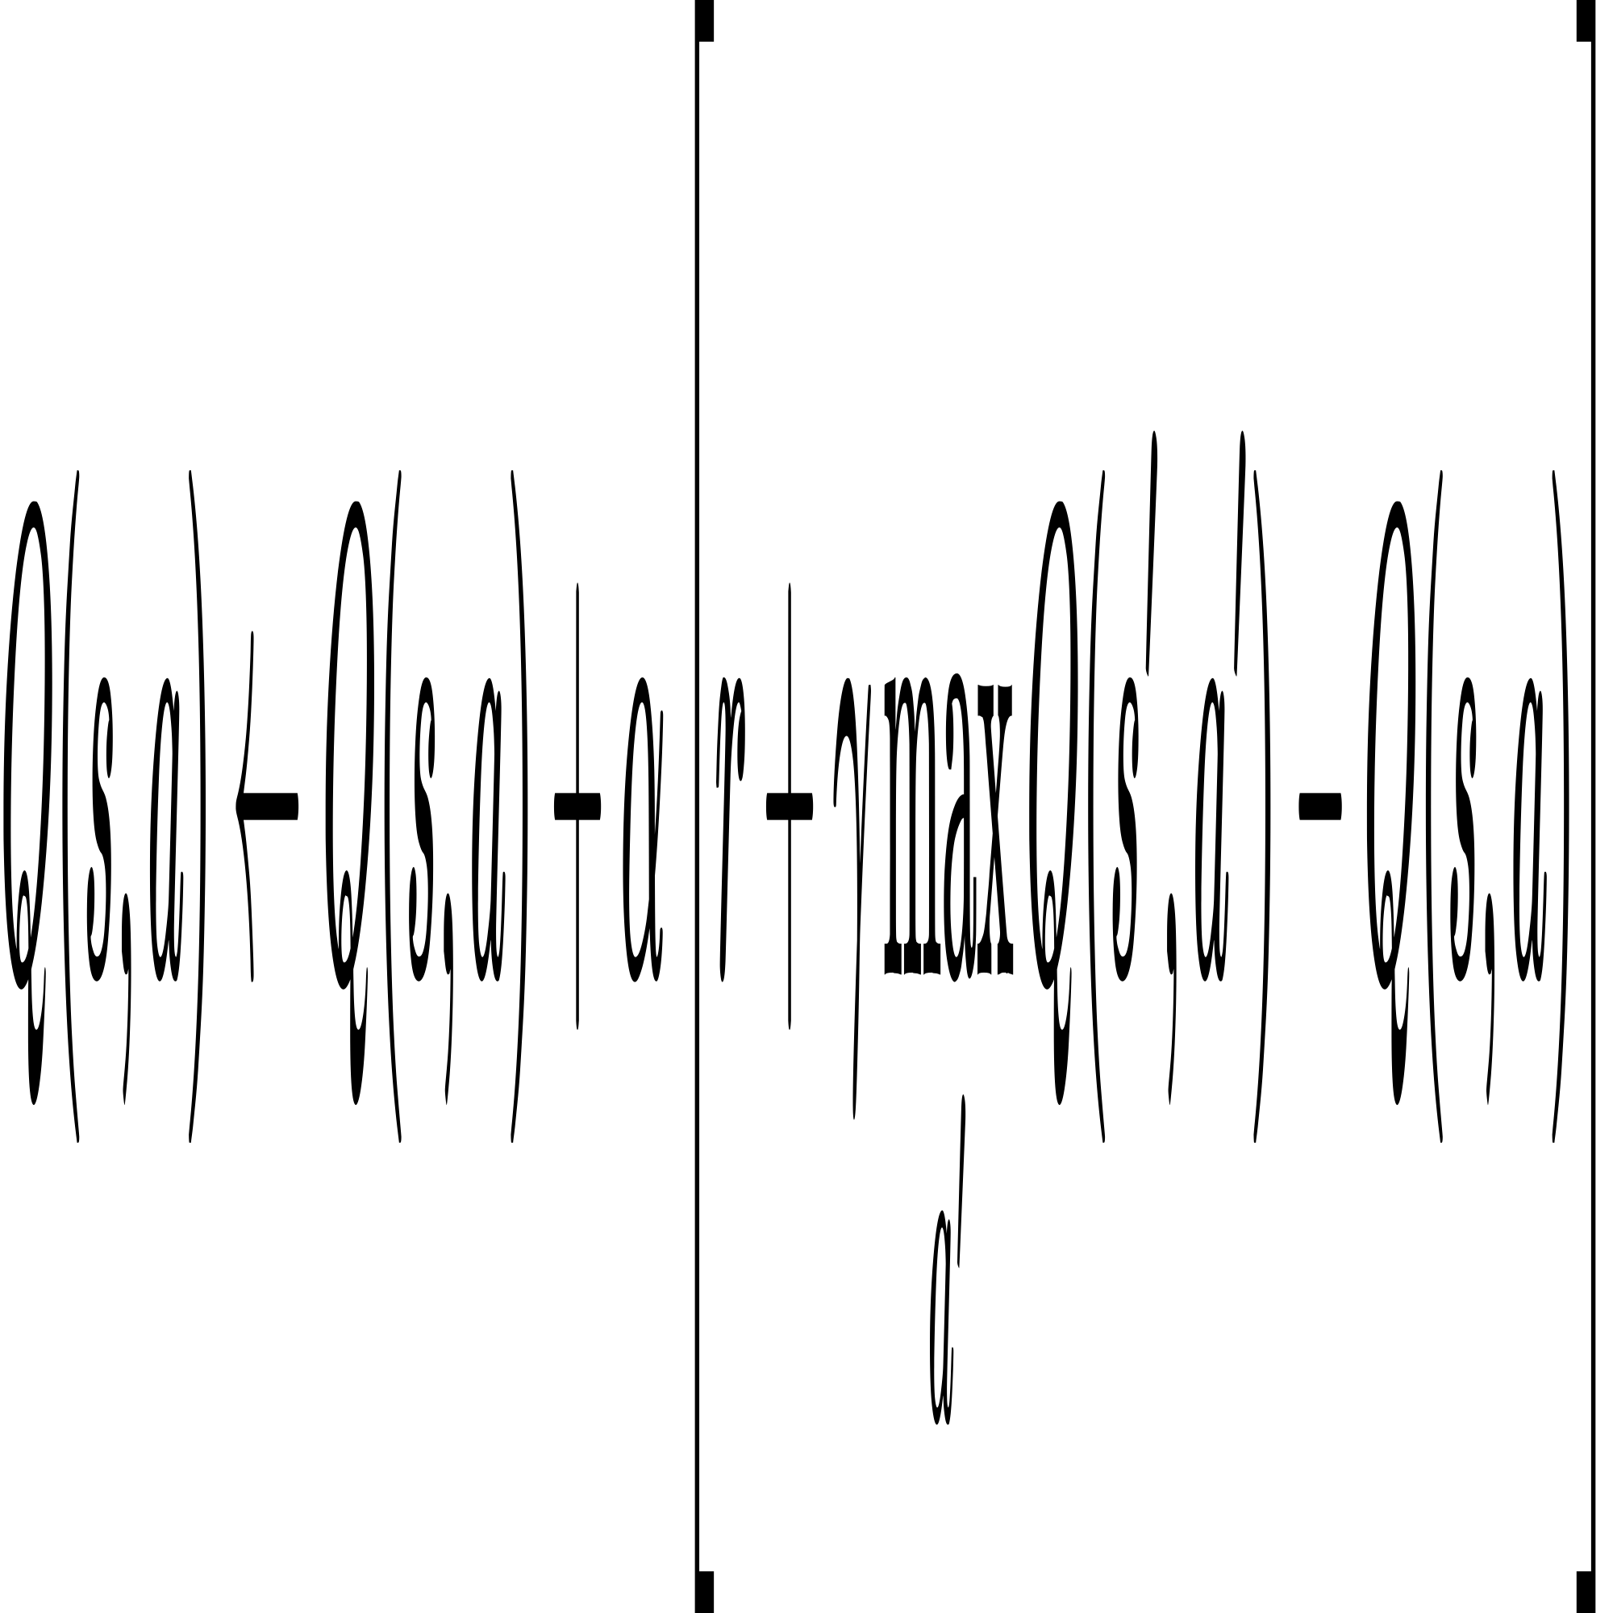

Where:

Q(s, a) = Current Q-value for state s and action 𝑎

a = Learning rate (0 < α ≤ 1)

r = Immediate reward received

γ: Discount factor for future rewards (0 ≤ γ ≤ 1)

s′ = Next state after taking action a in state s

a′= All possible actions in state s′

* Step by Step CH Selection Process:

**Step1:** State Observation

Each node observes three factors:

1. Residual Energy: Normalized to [0, 1], and discretized into: Low - Medium - High
2. Distance to Sink: Euclidean distance from the node to the base station (sink), also normalized and discretized into Near - Medium - Far
3. Round Phase: Current round r relative to the total simulation rounds Early - Mid - Late

These 3 features are combined to form a single state index from 0 to 26 (total of 27 states).

**Step 2:** Action Selection (ε-Greedy Policy)

Each node’s Q-learning agent uses its current state to decide whether to become a Cluster Head (CH) by choosing the action with the highest Q-value in that state.

For the current state s, the node picks an action a∈{0,1} using an ε-greedy policy:

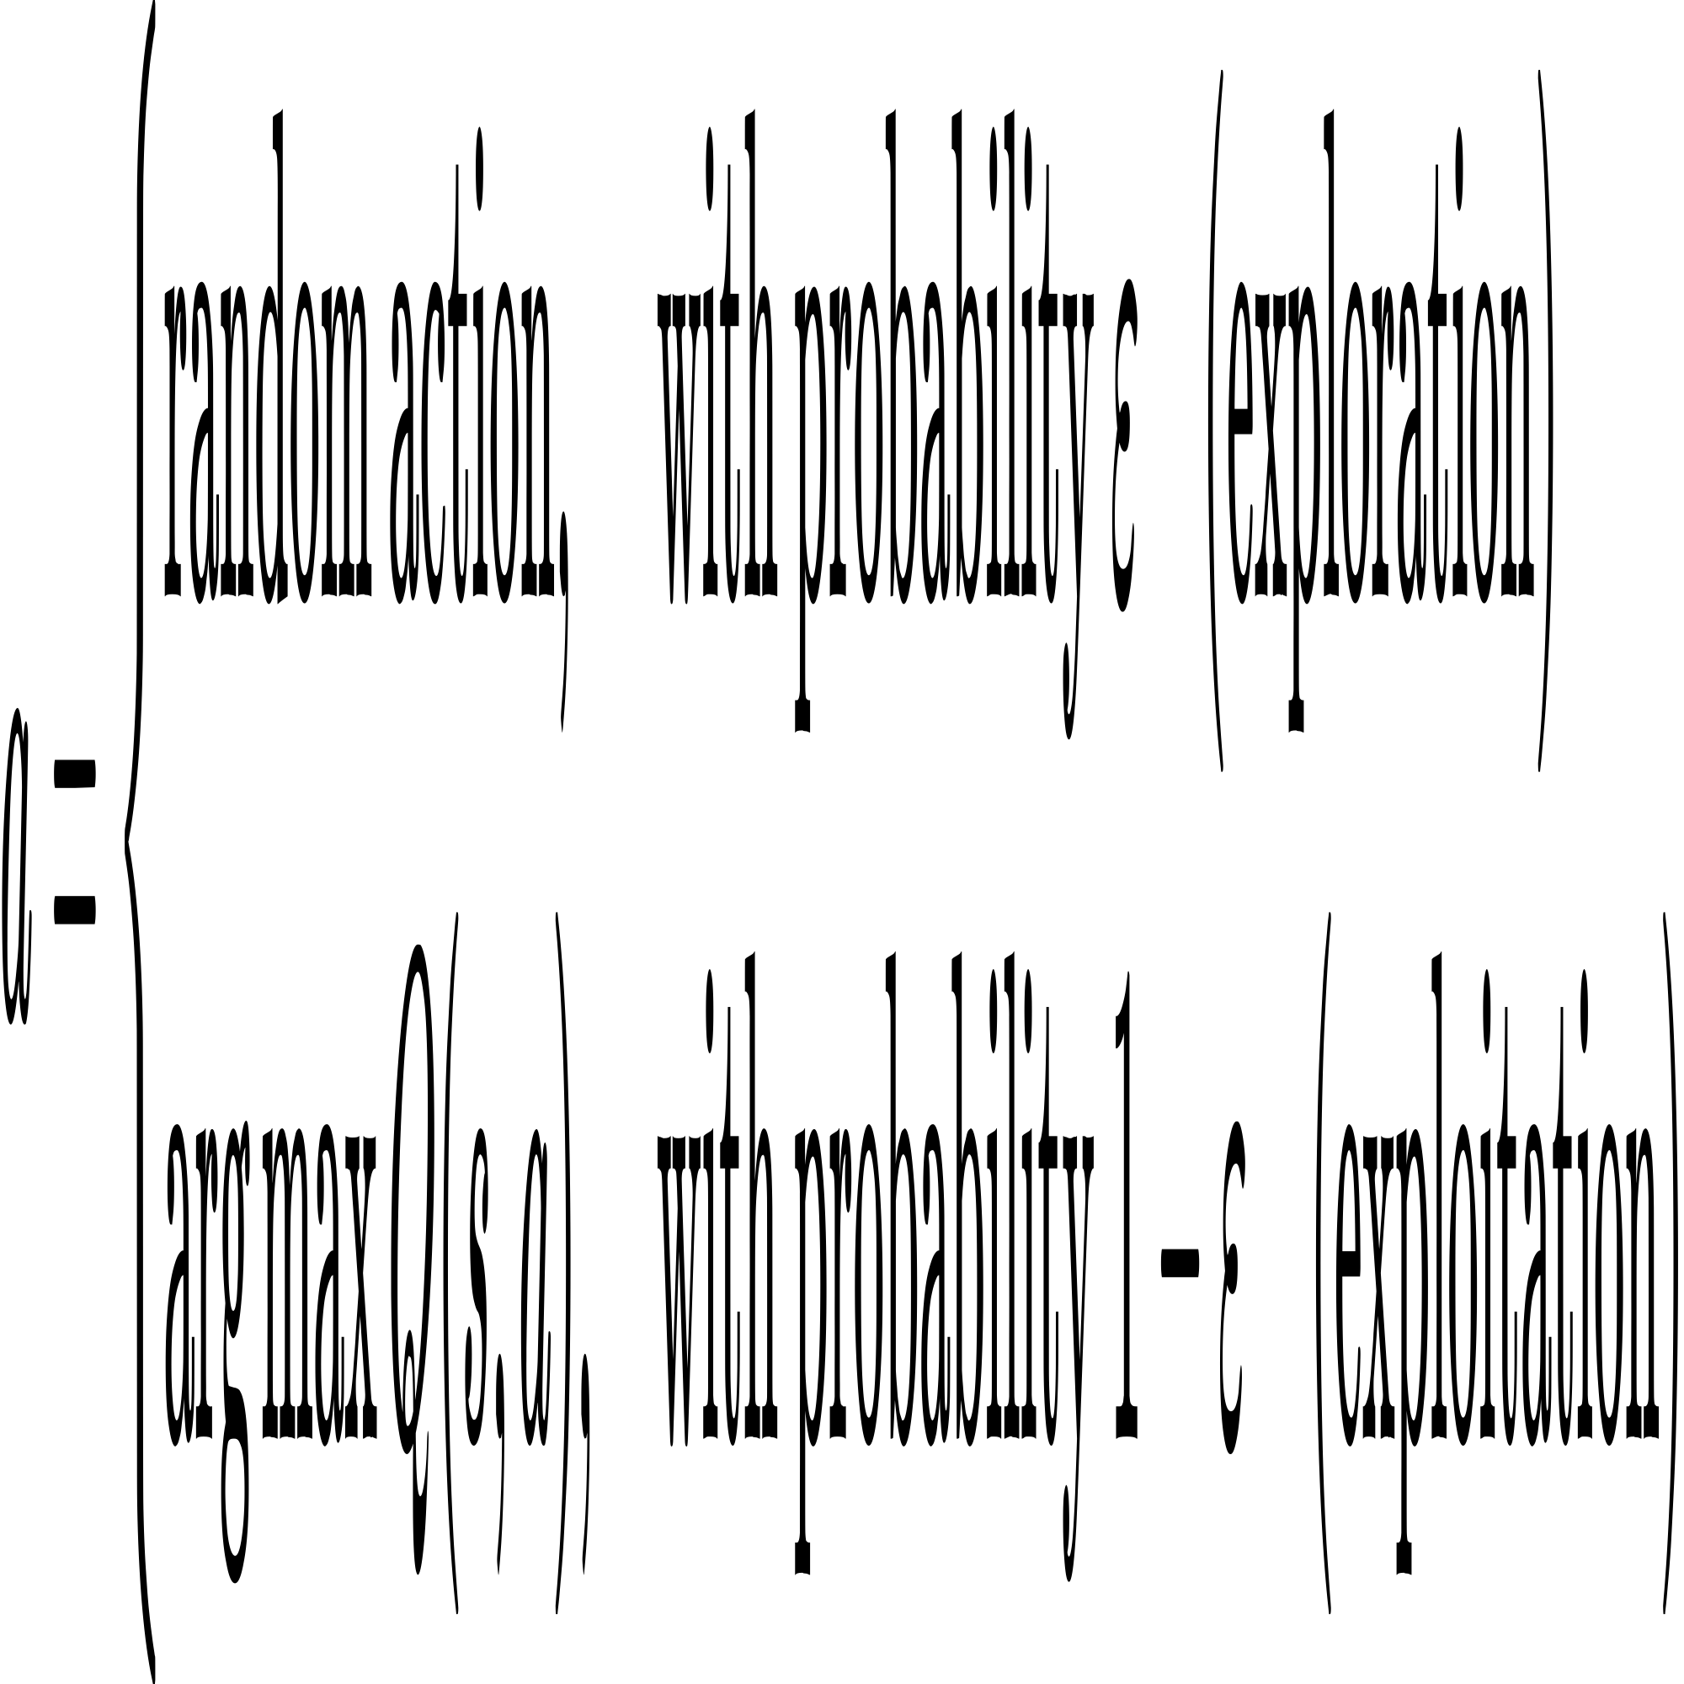

Exploration helps discover new strategies

Exploitation uses known best strategy from Q-table

**Step 3**: Cluster Head Declaration

If the selected action is:

1 → Node elects itself as a CH

0 → Node does not become a CH

The set of elected CHs for the round is now established.

**Step 4:** Reward Calculation (Post-Round)

After all tx and rx communication is done in the round:

Each node receives a reward based on its role, energy status, and survival

1. CH & survived: gets a shaped reward like:

C:/Users/SHUBHAM/AppData/Local/Temp/wps.fjqcoKwps

1. CH & died: gets a heavy penalty: r=−1.0
2. Not CH & survived: gets small reward proportional to energy r = 0.2
3. Not CH and died early or performed poorly: gets zero reward r = 0.0

**Step 5:** Q-Table Update



Where:

s = previous state

s ′ = new state

a = chosen action

α = learning rate

γ = discount factor

* Advantages:

1. Dynamic Adaptation
2. Autonomous and Distributed
3. Extended Network Lifetime

* Limitation:

1. Training Time Required
2. Sensitive to Hyperparameters